Sample Output Screenshots
Customer Table Created
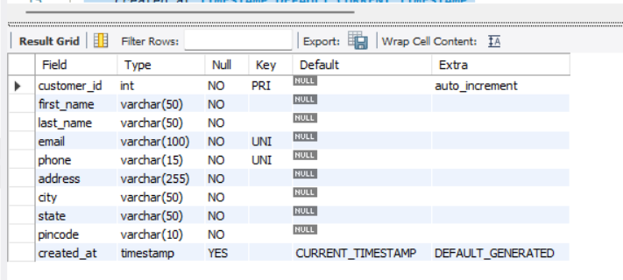

Inserted Customer Records

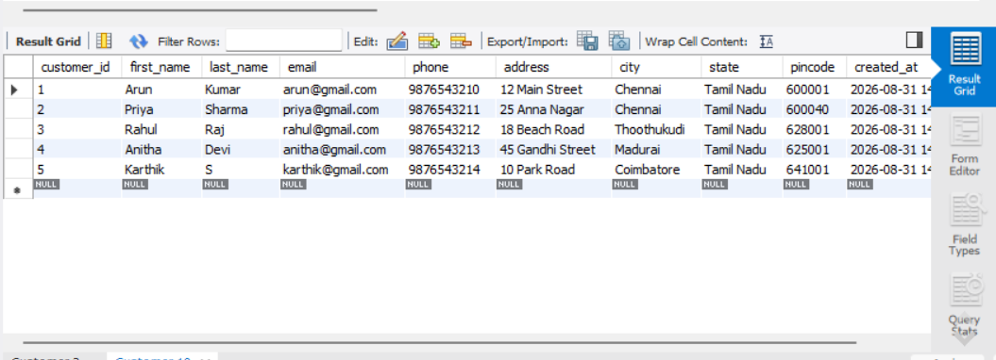

UPDATE Operation
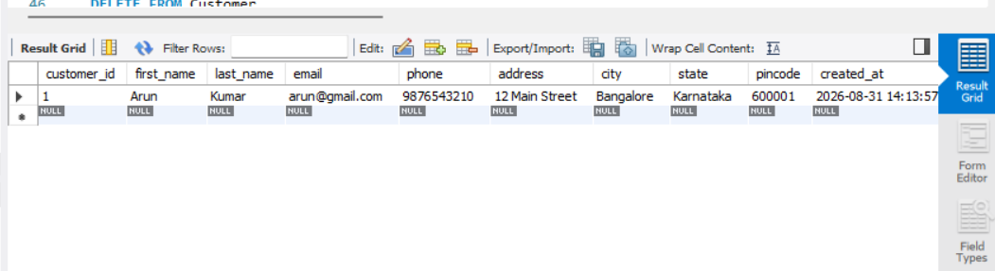

DELETE Operation

